Core Router

🌐 What is a Core Router?
# Source: AI Source: Provided by: [Data Path: Persons Table -> ID Column: 1, Name_En Column: Motasem Essam] -> From: [ChatGPT] on [12/18/2025]
A Core Router is a very high-capacity router used at the center (core) of large networks — such as internet service providers (ISPs), telecom companies, or large enterprise networks. Its main job is to quickly route massive amounts of data between different parts of the network, often at terabit-per-second (Tbps) speeds.

🔧 Key Characteristics of Core Routers
# Source: AI Source: Provided by: [Data Path: Persons Table -> ID Column: 1, Name_En Column: Motasem Essam] -> From: [ChatGPT] on [12/18/2025]
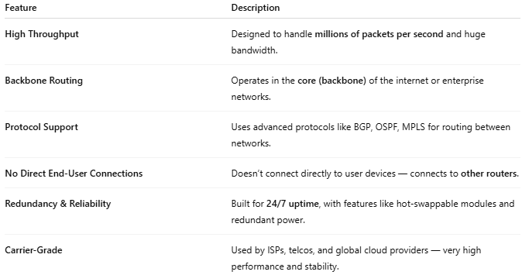

Feature | Description
High Throughput | Designed to handle millions of packets per second and huge bandwidth.
Backbone Routing | Operates in the core (backbone) of the internet or enterprise networks.
Protocol Support | Uses advanced protocols like BGP, OSPF, MPLS for routing between networks.
No Direct End-User Connections | Doesn’t connect directly to user devices — connects to other routers.
Redundancy & Reliability | Built for 24/7 uptime, with features like hot-swappable modules and redundant power.
Carrier-Grade | Used by ISPs, telcos, and global cloud providers — very high performance and stability.

🛠️ Where It’s Used
# Source: AI Source: Provided by: [Data Path: Persons Table -> ID Column: 1, Name_En Column: Motasem Essam] -> From: [ChatGPT] on [12/18/2025]
- At the core of an ISP network
- Between data centers
- As part of national/international internet backbones
- Inside large-scale enterprise networks with thousands of connected devices

📶 Network Layers: Where Core Routers Fit
# Source: AI Source: Provided by: [Data Path: Persons Table -> ID Column: 1, Name_En Column: Motasem Essam] -> From: [ChatGPT] on [12/18/2025]
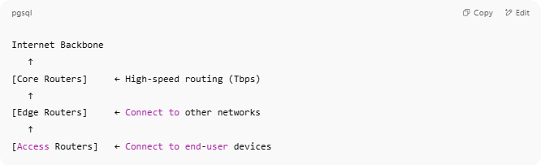

Internet Backbone
↑
[Core Routers] ← High-speed routing (Tbps)
↑
[Edge Routers] ← Connect to other networks
↑
[Access Routers] ← Connect to end-user devices

🖥️ Examples of Core Routers
# Source: AI Source: Provided by: [Data Path: Persons Table -> ID Column: 1, Name_En Column: Motasem Essam] -> From: [ChatGPT] on [12/18/2025]
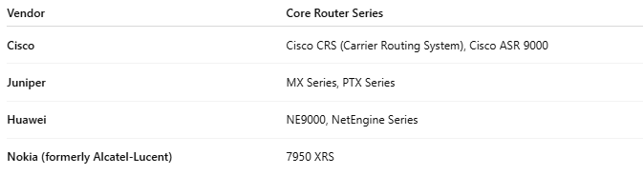

Vendor | Core Router Series
Cisco | Cisco CRS (Carrier Routing System), Cisco ASR 9000
Juniper | MX Series, PTX Series
Huawei | NE9000, NetEngine Series
Nokia (formerly Alcatel-Lucent) | 7950 XRS

🆚 Core Router vs Enterprise Router
# Source: AI Source: Provided by: [Data Path: Persons Table -> ID Column: 1, Name_En Column: Motasem Essam] -> From: [ChatGPT] on [12/18/2025]
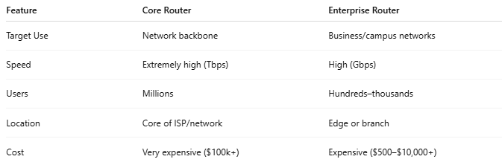

Feature | Core Router | Enterprise Router
Target Use | Network backbone | Business/campus networks
Speed | Extremely high (Tbps) | High (Gbps)
Users | Millions | Hundreds–thousands
Location | Core of ISP/network | Edge or branch
Cost | Very expensive ($100k+) | Expensive ($500–$10,000+)

Would you like a visual network topology diagram showing where core, edge, and access routers fit in?

